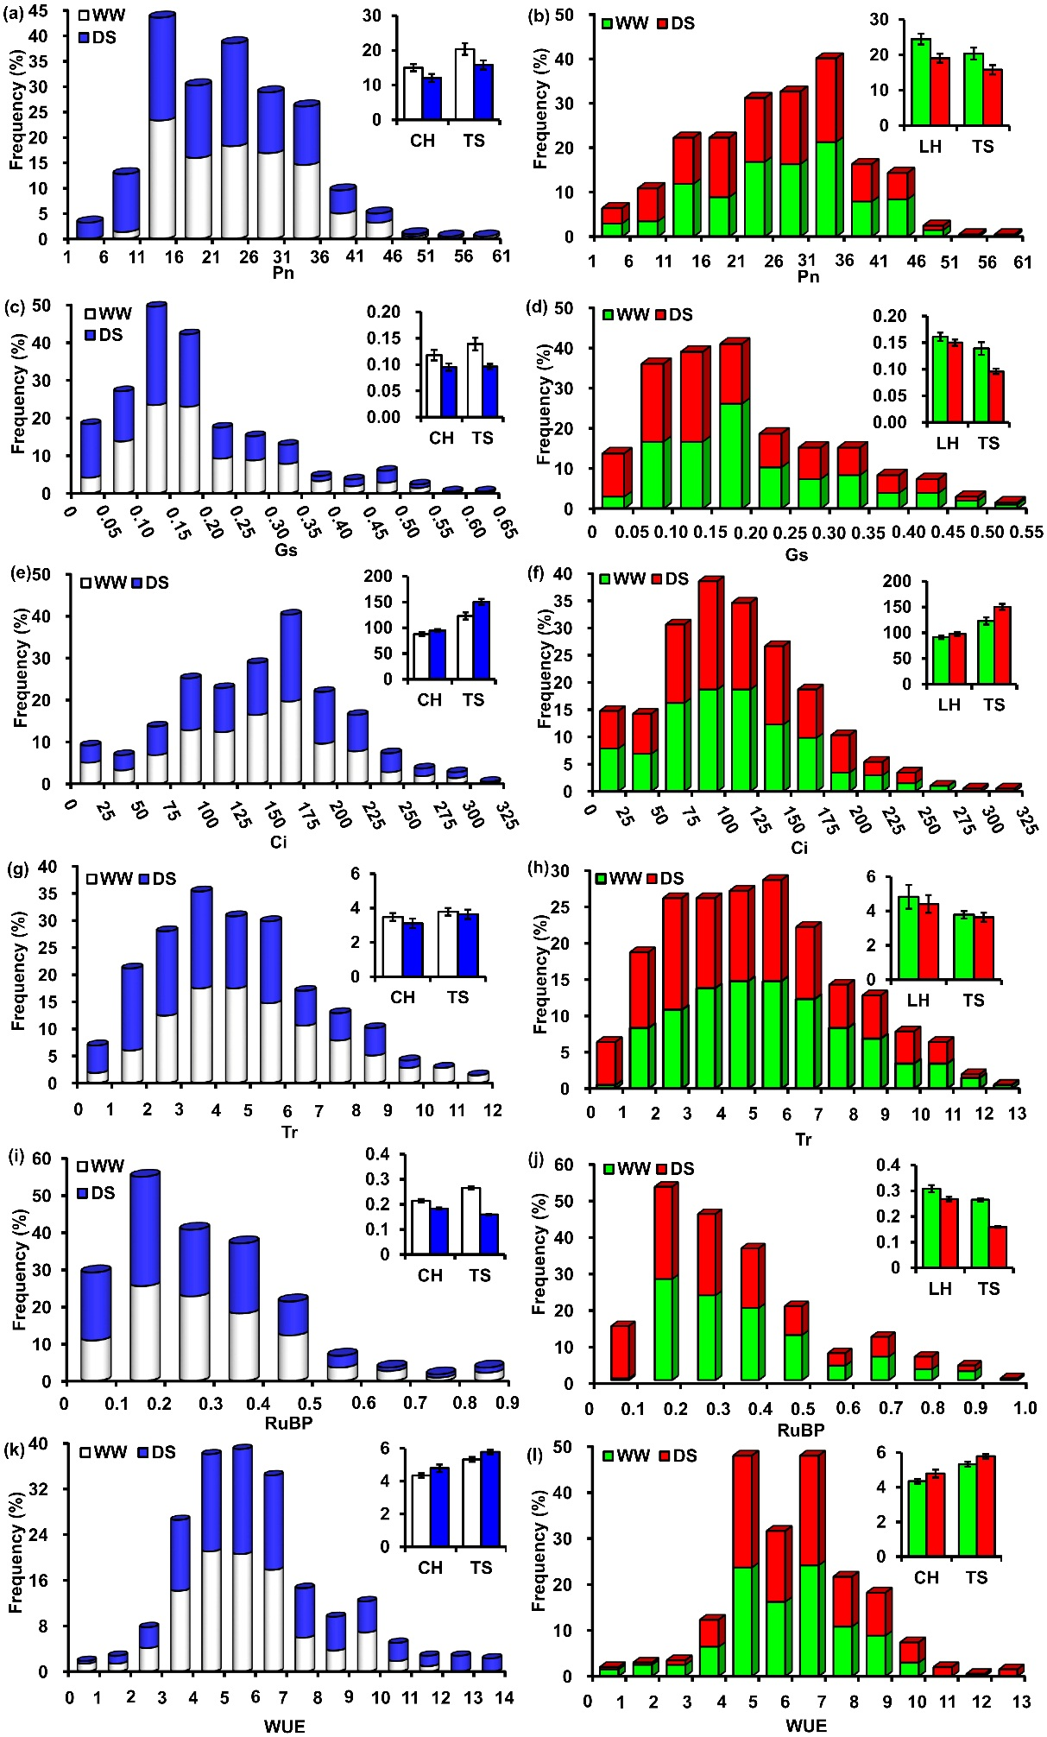
Additional file 3: Fig. S2 Frequency distribution of photosynthetic-related traits indifferent watering environments shown are Pn net photosynthetic rate (a, b), Gs stomatal conductance (c, d), Ci intercellular CO₂ concentration (e, f), Tr transpiration rate (g, h), RuBP ribulose 1,5-biphospate carboxylase activity (i, j), and WUE water use efficiency (k, l) of the two F_{2:4} families (POP-CT and POP-LT) derived from the cross of Chang7-2 (CH) × TS141 (TS) and Langhuang (LH) × TS141 (TS) under well-watered (WW) and drought-stressed (DS) environments

